ESCRIBE THE STARTING AND SPEED CONTROL AND EQUIPMENT OF A SLIP RING INDUCTION MOTOR.

STARTING AND SPEED CONTROL OF SLIP-RING INDUCTION MOTOR.

From figure 3.8.2 in the previous module it can be seen that a large rotor resistance is required to have maximum torque at low speeds and little resistance to have maximum torque at high speed. To be able to vary the rotor resistance, external variable resistance are connected to the rotor slip rings. Examples of this variable resistance are the liquid controller, the grid controller and the liquid starter.

Starting

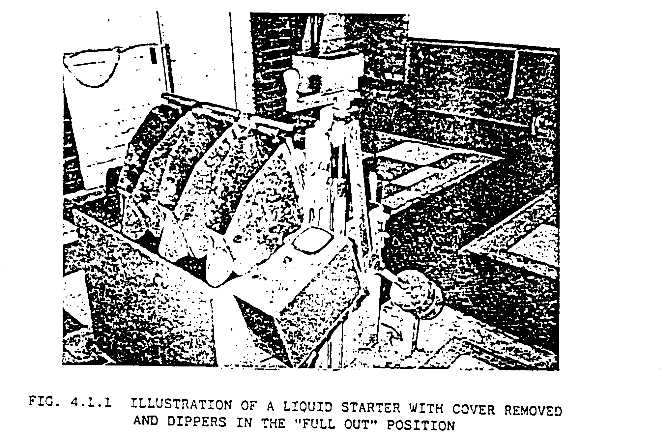The liquid starter (external resistance) is used for the starting of the induction drive motor of a M.G. set. During starting the resistance of the liquid starter is a maximum and the resistance is reduced as the motor gains speed until the resistance is short-circuit at full speed. Besides providing high starting torque it limits starting current.

Speed Control

For controlling the speed of an A.C. winder motor, the liquid or grid resistance controller is used.
Indirectly speaking there is no speed control, because speed depends on the load and the rotor resistance. This will be explained in more detail in the manual on A.C. winders.

Liquid and Grid Resistance Controllers

The liquid and grid resistance controllers are external resistances connected to the slip rings of the A.C. winder motor via brushes on the slip rings to give an electrical connection when the rotor turns.
The function of these controllers is varying the resistance in the rotor circuit.
Let consider the operation and construction of the liquid controller and the grid controller.
Please note that we are at this stage explaining only the function, construction and maintenance of each type of controller. The operation and control of the controllers will be explained in more detail in the manual on A.C. winders.

Liquid Controller

The liquid controller consists basically of three fixed and three moving electrodes in an electrolyte solution (one pair for each phase). The moving electrodes are sometimes operated by a servo unit. The closer the moving electrodes are to the fixed electrodes the smaller is the resistance. Thus by varying the distance between the moving elctrodes and the fixed electrodes the resistance is varied.
Now that you have a basic idea what the liquid controller is, lets have a look at the construction.

Construction

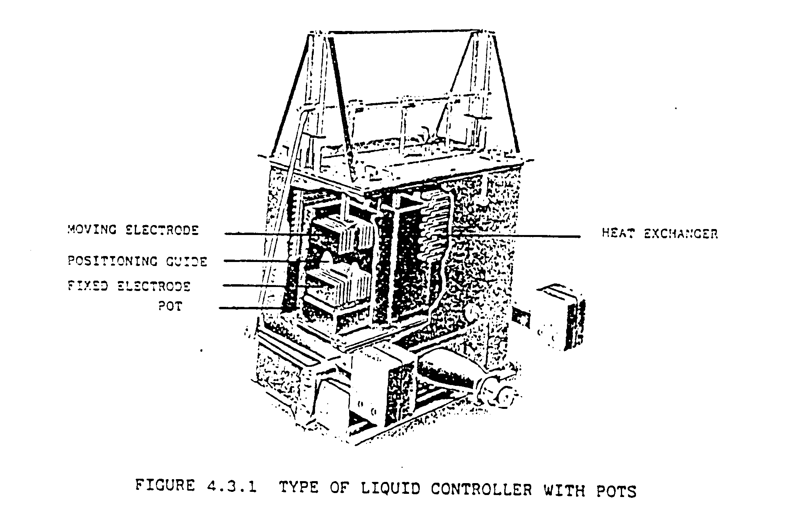Figure 4.3.1 and figure 4.3.3 show the two different constructions.

In the Above construction each fixed electrode is in a pot and the moving electrodes moves vertically up and down. All three pots are placed within a tank filled with an electrolyte solution. The tank is filled high enough so that all the pots are completely covered with electrolyte.
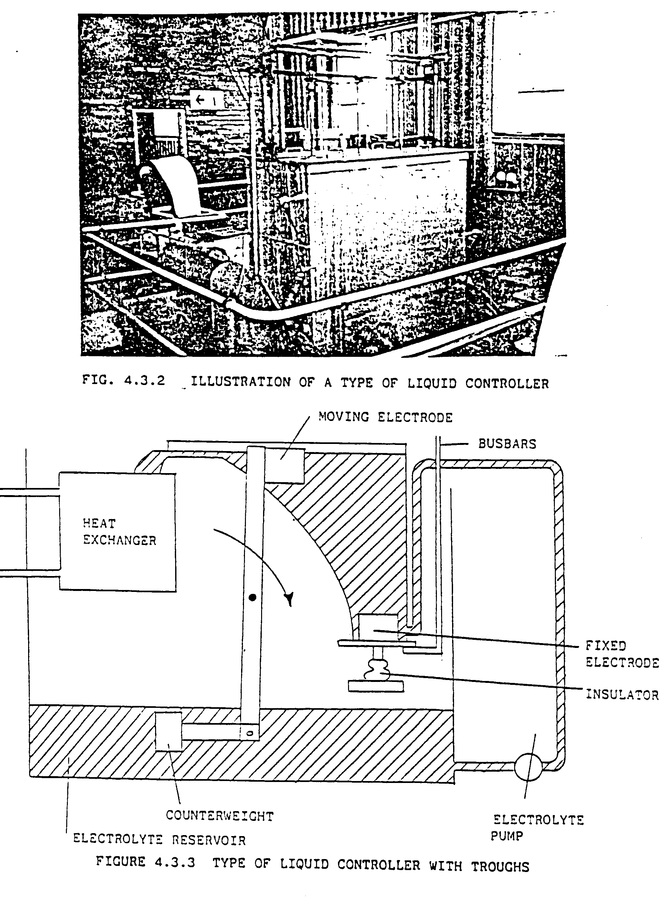
Figure 4.3.3 above is a simplified diagram of the second type of construction. In this construction the fixed electrodes are each placed inside a trough. Electrolyte is constantly pumped into each through and the trough is built in such a way that the electrolyte overflows into a reservoir from where it is again pumped back to the troughs.

Lets now consider the construction of each part in more detail.

Pots and Troughs

The fixed electrode are placed in pots or troughs because if not the current will flow direct between the fixed electrodes and thus movement of the moving electrodes will not have any effect on the resistance. The pots or troughs are made from insulating material to ensure that the currents flow only between the fixed and the moving electrodes. Although we will find that a certain amount of leakage will take place, as the electrolyte is common to all three phases. Therefore by varying the distance between the moving and the fixed electrodes the resistance is varied.

Electrodes

The fixed electrodes and the moving electrodes are cast with specialised material, e.g. phosphor bronze, and are constructed in such a way that each corresponding pair of electrode mesh without touching. Figure 3.3.4. Shows a pair of corresponding electrodes. It shows clearly how the moving electrode meshes with the fixed electrode without touching. (At any position the distance between the two corresponding electrodes must be the same).

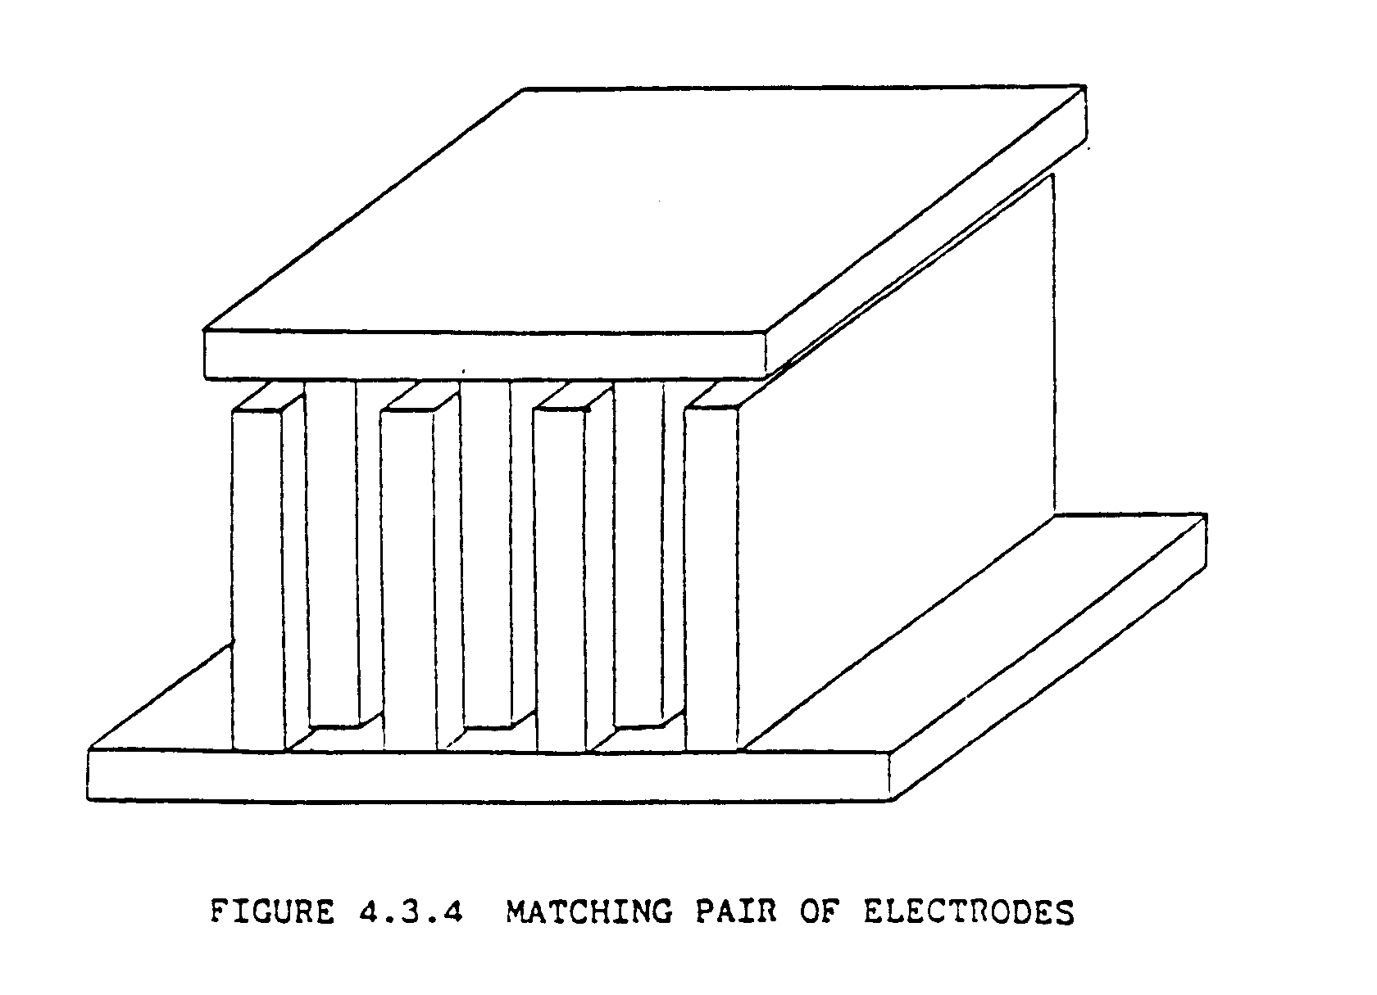It is important that the two electrodes do not touch, because if they do, it will burn thus cause damage to the electrodes. The moving electrodes are never completely out of the solution. In the full out position the roses of the electrodes are still inside the solution.

Fixed Electrodes

As previously mentioned the fixed electrodes are inside the insulating pot or trough. This is not the complete truth. Figure 4.3.5. Shows how the fixed electrode is actually bolted to the bottom of the pot or trough with the roses inside the pot of the trough, or in other words the pot is mounted on an outside flange of the fixed electrode. To ensure that the coupling does not leak, a gasket is used.
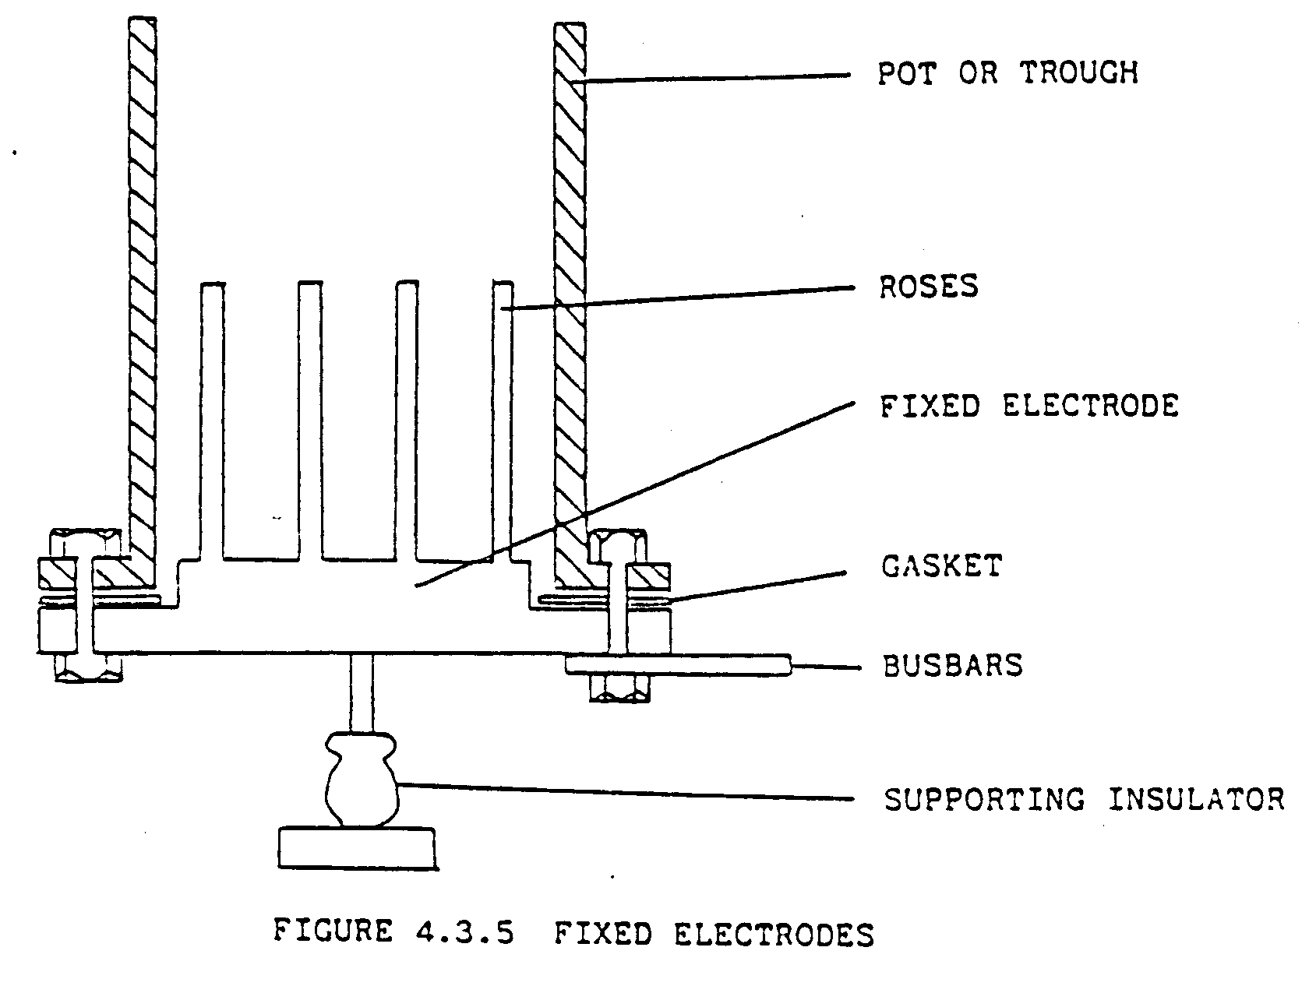
The fixed electrode and the pot are supported by an insulator to ensure that the pot is isolated.

In Figure 4.3.1 a positioning guide is indicated. This positioning guide is called the horn and its function is to prevent the moving electrode from meshing too deep, or touching the fixed electrode.
The fixed electrodes are connected to the brushes running on the slip rings by means of bus-bars or cables. To ensure a good connection to bus-bars must be solidly connected to the fixed electrodes.

Moving Electrodes

The moving electrodes, also called the dippers, are all three fixed to a moveable crosshead and are therefore simultaneously operated. The dippers are isolated from the crosshead, but are connected together to form a star point.

Since the torque the motor delivers, depends on the resistance of the rotor circuit, the resistance of each phase of the rotor circuit must be the same to ensure that they each deliver the same torque. Thus it is important that the resistance between each moving electrode and its corresponding fixed electrode must be the same.

To ensure the above, the moving electrodes (dippers) must have identical lengths and the crosshead must be level at all times.
It was also previously mentioned that the moving electrodes must be fixed in a position to mesh with the fixed electrodes, but not touch each other.

The resistance between each pair of corresponding electrodes, fixed and moving, can be measured with a multi-meter (which is set for resistance measurement) between each fixed electrode and the starpoint to ensure that the resistance are the same.

Electrolyte Solution

Caustic soda or washing soda is added to water to give a low enough resistance (See fig. 4.3.6)
NOTE: For washing Soda
Too little soda = weak solution - rotor starter resistance too high, motor will not start. (Low current).
Too much soda = strong solution - rotor starter resistance too low, draws high current, then starting and smooth acceleration will not be obtained.

NOTE: Caustic Soda

For Caustic Soda it is possible, by adding a large amount of soda, that the solution can become electrically more resistive (beyond point A).

Testing the Strength of the Electrolyte Solution

The conductivity of the solution can be tested with a conductivity meter. The correct value of conductivity is o be specified by the Electrical Engineer. If the conductivity is too high, the solution is too strong and water must be added.

Another way of testing if the solution is correct is by checking the starting current of the motor. If the motor draws too high current to start, the solution is too strong, and too low starting current means that the solution is too weak. The correct value of the starting current must be specified by the Electrical Engineer at a given temperature

Effect of Temperature on Electrolyte Solution

The conductivity of an electrolyte solution is affected by the temperature of that solution. If the solution is cold, its conductivity is low, and its conductivity increases with an increase in temperature. Therefore the temperature of the solution should be kept as constant as possible.

Adjustments to solution concentration and also conductivity tests should be done with warm solution.
To keep the temperature of the solution constant. The Electrolyte needs to be cooled. Usually during the colder winter months the electrolyte does not need to be cooled.

For cold start-up on winter Monday mornings e.g. the solution may be so electrically weak that the drivers may complain that the winter is sluggish and they will request you to add more soda. The recommended practice would be to bring the electrolyte to normal temperature by running the winder with maximum rotor resistance for a few trips up and down and then measure the electrolyte conductivity.

Cooling of Electrolyte

Because of currents flowing through the solution, the temperature of the solution rises. As the motor starts and stops frequently, the solution must be cold to prevent the temperature from rising too high. The method of cooling which is most used, is by having a heat exchanger inside the liquid controller. Cooling water is then pumped through the heat exchanger and thus removes the heat from the
electrolyte. The cooling water is then cooled with a cooling tower and re-used. The heat exchanger is shown in figure 4.3.1 and 4.3.3.

Operating Mechanism

The liquid controller is operated by a hydraulic servo-mechanism.
The oil flow to the operating cylinder is controlled by the transfer solenoid. Therefore if the driver gives power, the transfer solenoid allows the oil to flow to the cylinder.
As the rate of oil flow is limited by an orifice, the moving electrodes will move at a certain rate, even if the driver moves the control lever quickly to the full-on position.
Because oil pressure is required for the operation of the liquid controller a pressure switch is installed which trips the winder if the oil pressure of the servo system is lower than required.

Counterweight

The function of the counterweight is to return to keep the moving electrodes in the out position when the driver’s lever is in the neutral position. The counterweight is shown in figures 4.3.2 and 4.3.3.

Limit Switches

The following limit switches are on the liquid controller and they are used when the driver selects dynamic braking.
The function of operation of these limit switches will all be discussed together with dynamic braking in a later manual. The switches are:

(I) The torque control limit switch.
(ii) The power slow rate limit switch.
(iii) The off position interlocking limit switch.

Electrolyte pump
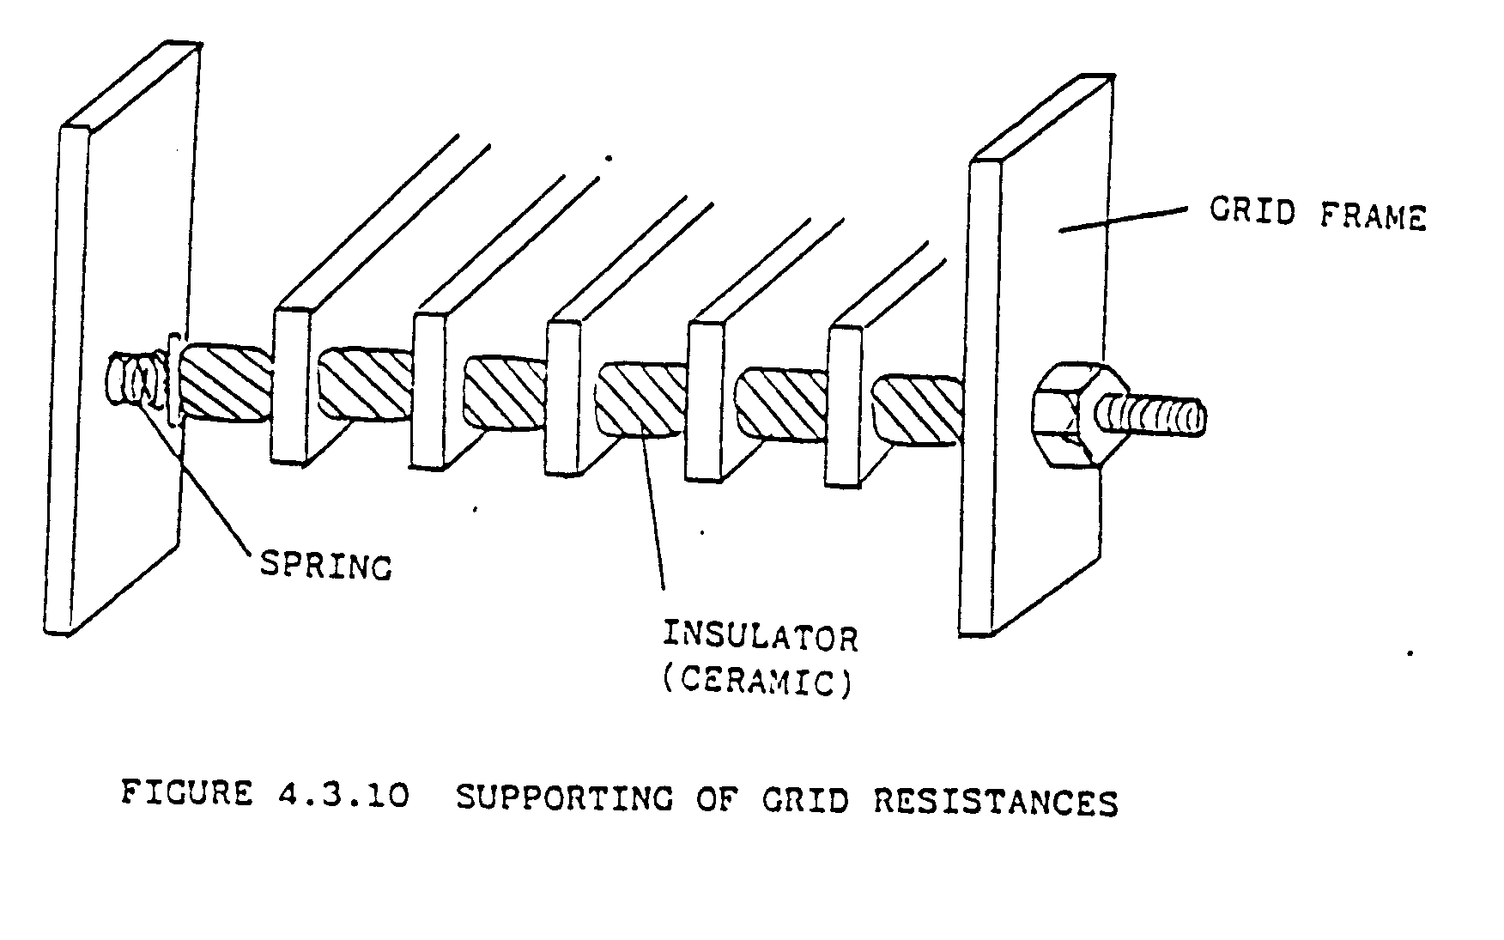
The function of the electrolyte pump is to circulate the electrolyte solution between the troughs and the reservoir. Figure 4.3.3 shows the circulation. Thus the solution inside the troughs, between the two electrodes where the heat is generated, is replaced.

Heat Exchanger and Cooling Pump

The heat exchanger cools the electrolyte solution. The heat exchanger is placed inside the liquid controller, and is covered with electrolyte. By pumping cooling water through the heat exchanger the heat is transferred to the cooling water. The cooling water is pumped by the cooling pump to the cooling tower where the heat is removed from the cooling water.

Grid Controller

Another type of variable resistance, which can be connected into the rotor circuit for speed control, is the grid controller. The grid controller consists of resistance’s connected in series and contractors are used to cut out resistance, or to insert more resistance in the rotor circuit. The contractors are operated via a master (drum) controller by the driver’s lever.

Lets consider the operation and construction of each component of the grid controller.

The Resistance’s

(a) Construction

The resistance is made of resistance material strips and are all connected in series. Figure 4.3.9 shows a bank of resistance for one phase only.
All the resistance is connected in series and their total resistance is the value of resistance, which is necessary for starting of the motor.

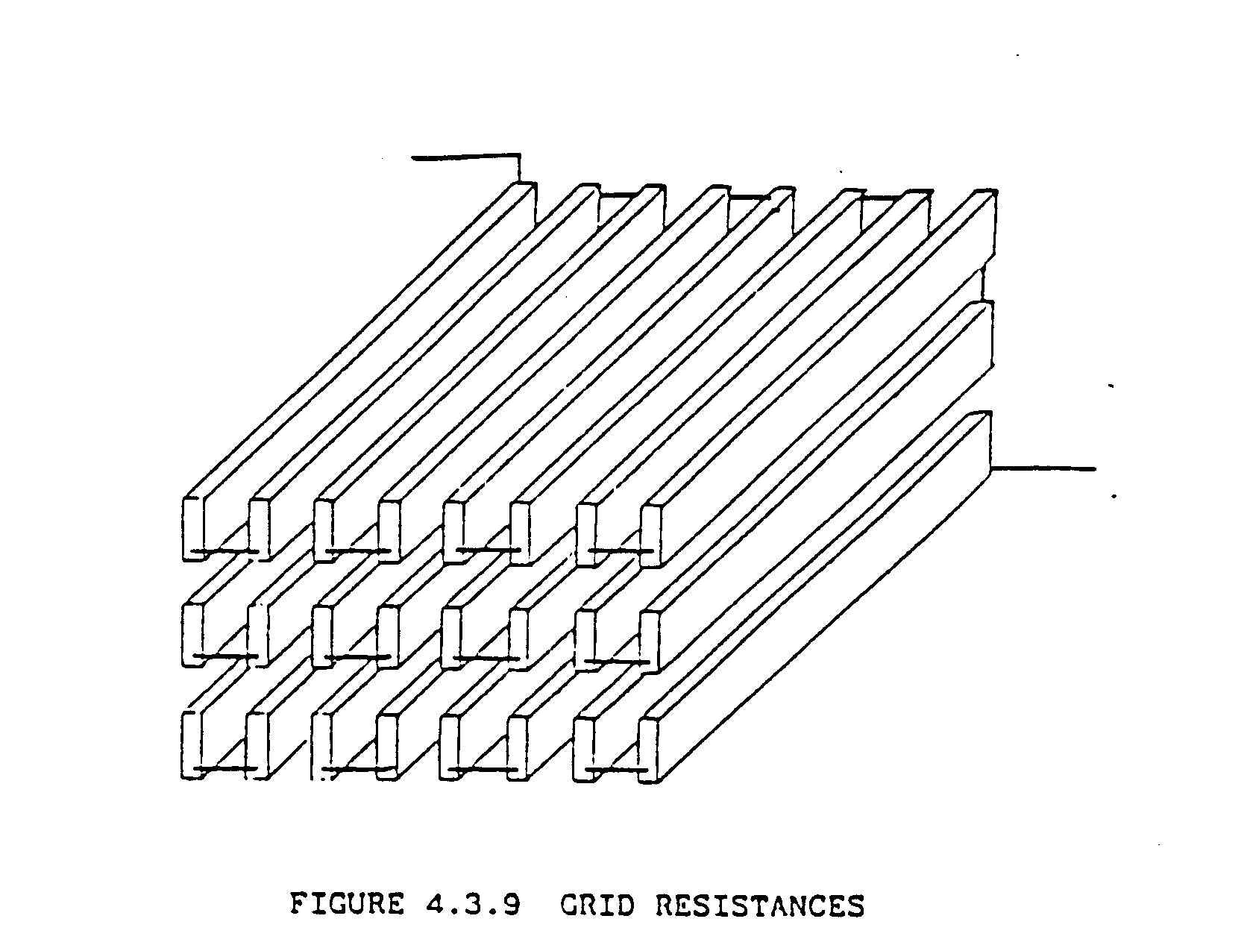The grids are supported by a bar, which is fastened to the grid frame. The grids are separated with ceramic insulators. They all slide onto the bar and are held together by a spring. Figure 4.3.10 shows how the grids are supported and insulated. (Only one layer is shown).

A spring is used to hold the grids together too allow expansion of the insulators and the grids.
This is necessary because if they are securely tightened the insulators will crack and break due to the expansion, which is caused by the heat.
It is important that the resistance’s don’t make contact, because if they do, some of the resistance is short-circuited.

Cooling of Grid Resistance

Because of the currents flowing in the grid resistances much heat is dissipated in these resistances. The best method to remove the heat is to force ventilate the equipment using clean filtered air obtained by a self-cleaning filter on the suction side of the fan.

Maintenance of Grid Resistance’s

Check all the insulators and ensure that the grid resistance’s don’t make contact.
Further check and ensure that all the connections are properly secured.

Contractors

Function

The function of the contractors is to short-circuit sections of grid resistance’s as the motor gains or reduces speed. The more contractors there are used, the smaller is the amount of residence, which is short, circuited at each interval and the motor will gain or reduce speed more smoothly.
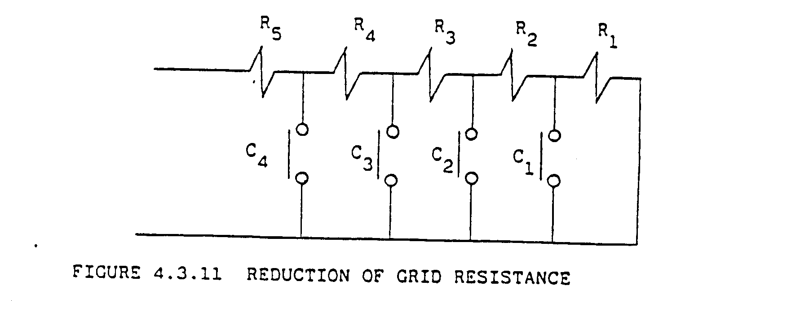To illustrate how the grid residence is reduced consider the diagram in Figure 4.3.11. The diagram shows the resistance and contractors for one phase only.

When the motor starts, all the contractors are open and the total residence is connected into the rotor circuit. That is R = R + R + R + R + R
To increase the motor speed, the master controller is operated via the drivers control lever and contractor C closes and this short-circuits R. The external resistance in the rotor circuit is now R = R + R + R+R.
Operating the drivers lever further in the same direction causes contractors C, C and C to close at different times and every time the external resistance’s are reduced as the motor gains speed.
The number of intervals by which the resistance’s is reduced varies and the above illustration is just to explain the concept. The higher the number of intervals, the more smoothly wills the gain of speed of the motor be, but it becomes uneconomical if too large number of contractors are used.

You will be learning more about this type of control system in the manual on A.C. winders.

Maintenance of Contractors

To remove the dust from the panels, the panels must be blown out with compressed air. The arc chutes of the contractors must also be wiped out, or washed with electrical cleaning solvent to remove the carbon build up inside the chutes. Also check the contacts of the contractors to ensure that they are still in a good working condition.

(c) Control of the Contractors

The opening and the closing of the contractors are controlled with a master controller who is operated by the drive’s lever. Thus the contractors are controlled by the driver’s lever via the master controller. This is shown if fig. 4.3.13.
The master controller is a drum type of controller with cams. These cams are set to operate switches, which operate the coils of the contractors. This will be explained in more detail in the module on A.C. winders.

4.4 Slip Rings

As mentioned previously external resistances must be connected in the rotor circuit to control the speed of the motor. The rotor windings are brought out and are connected to three slip rings. One for each phase. This shown in Fig. 4.4.1.

The slip rings are usually made of bronze or cooper-nickel, which have a high resistance to wear. The slip rings are shrunk onto an insulated bush, which in turn pressed on the motor shaft.

4.4.1 Maintenance of Slip Rings

Inspect the slip rings that they have nice smooth surfaces, if not the brushes will not make good contact and will also wear down quickly.

All the carbon and dust between the slip rings should be removed to prevent any flashover the slip rings. The carbon and dust can be blown out with compressed air but if this is not adequate electrical cleaning solvent must be used.

4.5 Rotor Short-Circuiting Gear

On the mines this is usually found on the slip ring induction motor of a M.G. set. The slip rings of the wound rotor induction motor have a short-circuiting device, so that the leads and the liquid controller are used only during the starting periods. In the case of the slip ring induction motors on M.G> sets, slip ring brush-lifting gear is also fitted, and is operated after short-circuiting of the rotor. This decreases wear and tear on the brushes and rings.
The operation of the short-circuiting gear “practically” converts a wound rotor into a squirrel cage rotor, with quite a low resistance:
this is, of course advantageous, since although resistance in the rotor is of assistance in starting, it is undesirable from the point of view of efficiency when running.

When starting a M.G. set slip ring induction motor, the motor CCB is switched in and then the liquid starter is slowly turned “in” to cut out the external rotor resistance until the motor is up to full speed. With the liquid starter in “full in” position the liquid starter short circuits the rotor. Only then may the rotor short-circuiting gear be turned in, which will short-circuit the rotor and the brushes will be lifted off the slip rings.
(See illustration)

Figure 4.5.1 illustrates the three slip rings and the short-circuiting collar.

The short-circuiting device is usually operated by turning a wheel and gears or on some new winders a small electrical motor. Also with a mechanical arm operated by hand. (As shown in Fig 4.4.2a).

This device which is used to operate the short-circuiting collar is usually constructed such that it lifts the brushes if the wheel is turned further after the short - circuiting collar has already been engaged to short-circuit the rotor.

To ensure (during starting) that the short-circuit is removed and the liquid starter is in the “out “ position, they are electrically interlocked with the main OCB. Thus the OCB will not close for starting up if the short circuit is not removed (in the “out” position).

4.5.1 Starting on the M.G. Set Drive Motor

(a) Turn out the rotor short-circuiting device.
(b) Turn the liquid starter to the “full out” position.
(c) Press the start button. (on starting console).
(d) Slowly turn the liquid starter in as the motor gains speed until the “fully in” position.
(e) Turn the short-circuiting device in and keep on turning until the brushes are lifted.
(f) The motor is now running at full speed and the external resistance is removed.

it is important that you realise that this short-circuiting device is only used on the AC motor of the M.G. set. The external residence on the AC winder drive motor should never be short - circuited. Make sure that you do not get confused.

Advantage and Disadvantage of the Induction Motor.

Advantage of the Induction Motor.

(a) Require no means for its excitation other than the AC line
(b) Low manufacturing cost.
(c) Possibility of having speed control by placing external resistance’s in the rotor circuit.

Disadvantages of the Induction Motor

(a) Its speed decreases slightly with increasing load torque.
(b) Bad power Factor.
(c) Speed control as in (c) above is wasteful of energy.

Dynamic Braking

Dynamic braking is a method of applying electrical braking to reduce the speed of an AC winder before the mechanical brakes are applied.

Dynamic braking will be described in more detail in the manual on AC winders.

Cooling of A.C. Motors

The synchronous and the induction motors should be ventilated with filtered air cooling. This prevents the build up of dust inside the ventilating ducts and removes the heat out of the motor.
Small enclosed induction motors usually have a fan mounted on the shaft which blows air over the stator core for cooling.
A.C. winder drive motors should be well ventilated, because due to the continuous starting and applying of dynamic braking for stopping, much heat is generated inside the motor.

Maintenance of A.C. motors

The motor should frequently b blown out with dry compresses air to remove all dust accumulated on the windings and inside the ventilation ducts. Dust accumulating on the windings prevents the dissipation of heat and the motor might overheat.
All windings should be examined to ensure that the windings insulation is not cracked or discoloured. If the insulation is discoloured it is an induction of overheating. All dirt and oil should also be removed with electrical cleaning solvent.
The brushes should be checked to see if they have not worn down too much. The length of the brushes before it needs replacement must be specified by the Electrical Engineer. The brushes should also be bedded to ensure a good contact with the slip rings.
Examine the brush holders to see that the brushes slide smoothly in the holders. If the brush can move around in the holder, the holder has worn and needs replacement. Check that the holder is not too far away from the slip rings. the distance should be between 2 and 2,5 mm.
On M.G. sets where a short-circuiting device and brush lifting gear are installed check to see if the collar moves easily on the shaft and that the mechanical parts are all in good condition. All parts must be cleaned and lightly lubricated. the bronze slippers must be checked for wear as slightly greased. the contacts on the collar and slip rings must also be cleaned and lightly lubricated with Vaseline.
Future ensure that everything is clean and in good condition.

